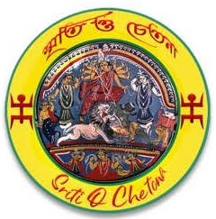

BANGLADESH HINDU PERSECUTION
2026 BI-ANNUAL REPORT
January 2026 - June 2026
Published by
Sriti O Chetona (Memories and Consciousness)
July 2026

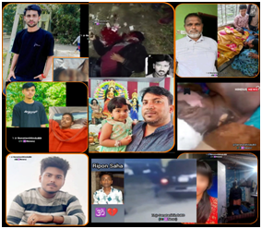 | 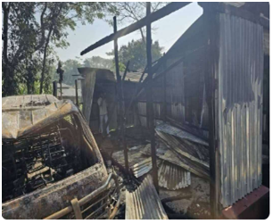 | 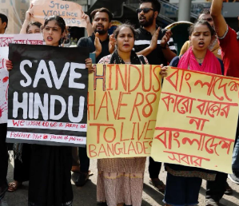

Overview for January 2026- June 2026) | 3
Recommendations | 7
Property Rights, Religious Discrimination, and the Legacy of the Vested Property Act - Executive Summary | 15
Appendix - 1: Persecution Categories Compiled by SoC | 24
Appendix - 2: Administrative / Geographical Division of Bangladesh | 25
Appendix - 3: Incidents of Persecution (January 2026- July 2026) | 26

The plight of minorities in Bangladesh continued to worsen every year, with Hindus and indigenous tribal populations facing acts of aggression such as abuse, looting, destruction, kidnapping, rape, murder, eviction, and coerced conversion to Islam. As the minority demography shrinks, the intensity of adversity faced by them increases. This report provides an overview of the incidents compiled by Sriti o Chetona (SoC) from public information (including photos) that are available on social media and news portals. This report provides an overview of the atrocities committed against these communities in Bangladesh from January 2026 to June 2026.

Overview (January 2026 - July 2026)
In this report, we analyzed the incidents of persecution primarily by following metrics:
- Persecution category (collated by SoC team). The complete list is provided in the Appendix - 1
- Administrative and geographical division
- Victim’s social group (individual, community)

In addition to the above-mentioned metrics, we will also investigate the data by month of the year, religious belief, gender and age of the victims.

It is to be noted that SoC has compiled the data by incidents reported in news and social media. Without access to police reports and ground information about the victims, it is not possible to give accurate counts, hence we abstained from reporting details about the victims.

We chose to report by the victim's social group and categorized the incidents by individual or community. In 2023 we had reported incidents by three categories (individual, family and community), but found it is difficult to discern victims between individual and family in multiple cases. To report in an unbiased manner, we decided to report only by two categories, individual and community.

We also acknowledge that we have been able to gather information for only a fraction of total incidents. Hence, it was decided to analyze data with the sample collected, and not by absolute number. We feel that statistically the distribution of categories of persecution incidents collated by the SoC team will follow the pattern in real life.

As we see in the chart below, the top five persecution incident categories are; “Destruction or desecration of temple / shrine / image”, which constitutes 18.5 % ( was16.3% in Q2 2025), Murder / Mass Murder account for 16.3% (unchanged from Q2 2025), “Physical Assault / torture / beating / threat / intimidation to leave country” account for 12.2%, “Land grabbing / Eviction by force / forgery / manipulation” account for 9.2% and “Insult / Public humiliation / Hate speech / Hinduphobia / Anti-Hindu slurs / Abuse” account for 7.6% of total incidents .

Persecution by Category (by % of total incidents reported in 2025)
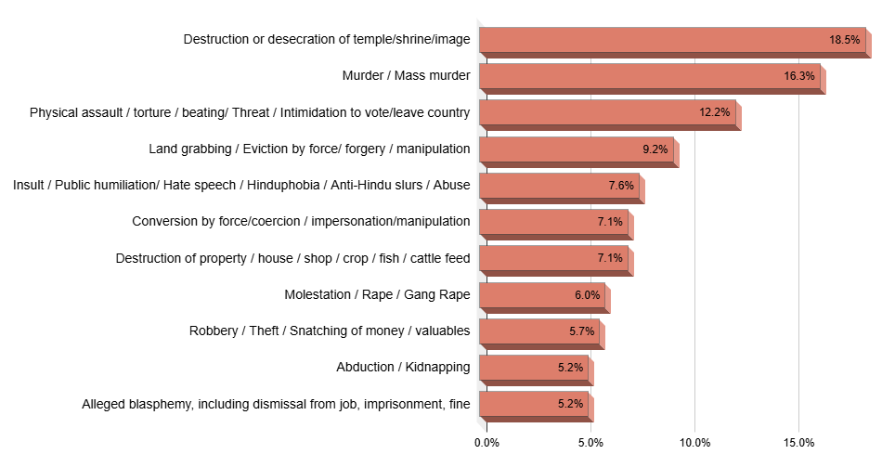

Temple destruction and desecration continues to top the list in 2025, as was the case in the prior two years that was reported earlier. It is to be noted that the number of persecution incidents went up sharply. The total number of atrocity incidents analyzed by the SoC team went up by 30% in 2025 compared to the same period in 2024.

In the charts below, we analyze the percentage of Hindu population density (2011 census) with all incidents of atrocities recorded in 2025 YTD. The darker color indicates a higher percentage. It is noted that Dhaka (29.1%, was 34% in Q2 2025) and Chittagong (17.9%, was 18.1% in Q2 2025) have the highest percentages of persecution incidents, even though the Hindu population density is not high in the above divisions.

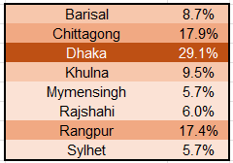  Incidents by Division | An exception to the trend compared to the last few years is Rangpur, which accounted for 17.4% of total incidents, which had shown a sharp increase after the fall of Sheikh Hasina govornment. “Khulna”, with a highest percentage of Hindu population contributes to 9.5% (8.8% in Q2 2025) of the incidents. Mymensingh and Sylhet each accounted for 5.7% each and were the lowest number of incidents among the geographical divisions.
A small number of incidents were also reported in Online/Book/Social Media.

Hindu Population Density - 2011 Census | Persecution % by Division: Jan - Dec 202
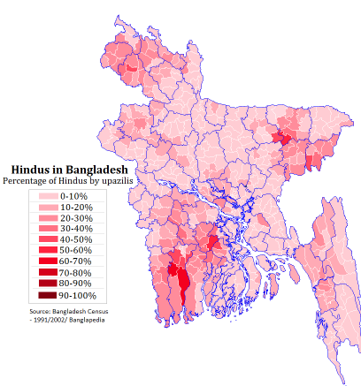 | 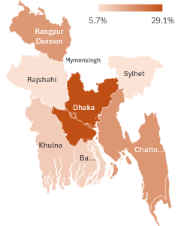

Persecution by Victim Group  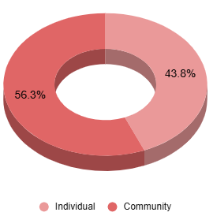 | When data is analyzed by the victim's social group, the attacks in temples and other community properties or general anti-Hindu slurs, mass threat for conversion, expulsion from the country and abuse (both online and in-person) are considered affecting the whole community, which accounts for 56.3% (58.9% in Q2 2025) of the victim group.  Most of the individual victims faced abduction, rape and forced conversion in case of women and accusation of blasphemy, physical assault and murder in the case of men.
Among individual victims, men account for 57% (55% in Q2 2025) and women 43%. Land grabbing affected both individuals (personal property) and community (temple endowed lands).

When the total number of incidents recorded by the SoC (Sriti O Chetona) team was analyzed by month, the numbers had uptick in January, April and May. A similar trend was observed in 2024 during the same period. The increase in hostility in the month of April happens due to religious detestation of observing Bengali New Year in secular celebrations. Incidents also increase during Eid Al Adha fasting and religious observance by Muslims, which lead to religious fervor and vigilance among the adherents. There have been multiple incidents of assault and in some extreme cases leading to murder of non-believers for keeping restaurants open or eating and drinking during the time of fasting.

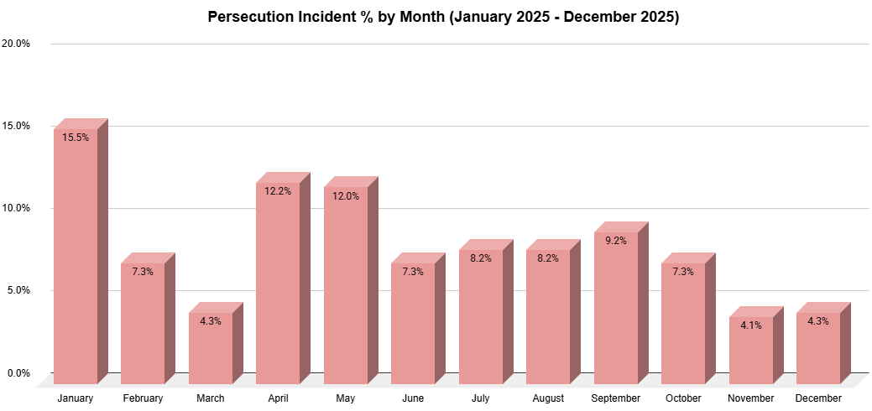

When we analyze data by age, majority of the minors are females facing abduction, rape, forcible conversion and marriage. Looking into the data by gender (in cases where individuals are identifiable), male victims constitute 55% of the victims. The type of persecution varied between males and females.

Looking into the total number of persecution incidents collected, most of the persecution incidents are targeted against Hindus and indigenous people. Attacks on the indigenous community have increased since July 2024, with increased number of cases of land grabbing and molestation and rape of women and children. Christians, liberal Muslims, Ahmediya Muslims and atheists are also targeted, albeit less in number, possibly due to smaller demographics.

Recommendations

Backdrop
As per the latest 2022 census, the total population of Bangladesh is 165.16 million. Religious minorities constitute about 8.98% of Bangladeshi population, constituting 14.83 million. Hindus are the biggest religious minority group, with 88.5% of total minority population.

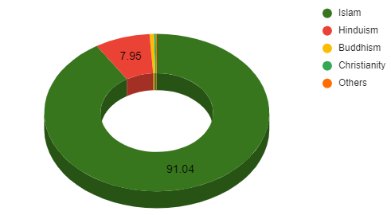 | 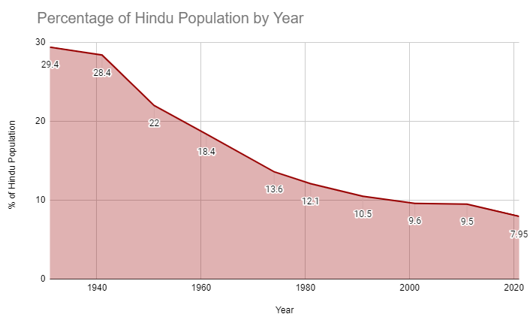
Religions in Bangladesh (%) - 2022 Census Data | Decline in Hindu population in Bangladesh

Since the 1947 partition of India, Hindu population in East Pakistan/ Bangladesh is continuing to decline. The persecution of Bengali Hindus under the Pakistani regime is well recorded, especially during the Bangladesh war of independence. In less than a year during 1971 Bangladesh war of independence, approximately three million Bangladeshis were killed, a rate worse than The Jewish genocide of WW2 by Nazis. It is estimated that Hindus were about 20% of the population during that time, but the overwhelming majority (~80%) of the victims of Pakistani brutality. From 1947 to 1971, Hindu population fell from approximately quarter of the population to mere 13.5%. 1971 heralded a new hope among Bangladeshi Hindus under a secular constitution drafted by Sheikh Mujibar Rahaman’s govt. However, the hope was short-lived, and Hindus faced hardship by Islamists under political aegis of various governments. It is also to be mentioned that General Ershad, who assumed power through a military coup, amended the constitution in 1988, to add Islam as the state religion. In the post-independence period, the first major anti-Hindu violence occurred in 1989-1990, following the Babri Mosque-Ram temple conflict in India. There was widespread destruction of temples, arson, looting and violence against Hindus.

Another major anti-Hindu attack happened in 2001, following the election of the Bangladesh Nationalist Party (BNP) government led by Ms. Khaleda Zia. According to judicial enquiry by Bangladesh government in 2009, more than 18,000 rapes of Hindu women happened during the riots. In October 2021, a frenzied coordinated communal attack happened all over the country following rumors of Quran desecration, which was later found to be done by a Muslim named Mohammad Iqbal Hossain. More than 50 temples were vandalized and at least eight people were killed. On March 2, 2023, the main culprit, Mohammad Iqbal Hossain was sentenced to 16 months imprisonment. The leniency of Mohammad Iqbal Hossain’s punishment is indeed extremely shocking. A month earlier, in February 2023, a Hindu Bangladeshi named Paritosh Sarkar was sentenced to 11 years imprisonment for hurting religious sentiments of Muslims. In January 2023, another Hindu man Rakesh Roy was sentenced for 7 years imprisonment for alleged blasphemy in a social media post. The discrepancy in severity of punishment between a Muslim and a Hindu for similar accusations (blasphemy) is noteworthy.

Bangladeshi minorities created 13 platforms to combat anti-religious sentiments following the July revolution. They organized multiple rallies under the auspices of “Sanatan Jagran Manch” for eight demands, including a tribunal to expedite trials against minorities, compensation and rehabilitation of victims and enacting minority protection laws. They organized multiple rallies throughout the country under the leadership of ISKCON monk Chinmoy Das Prabhu.

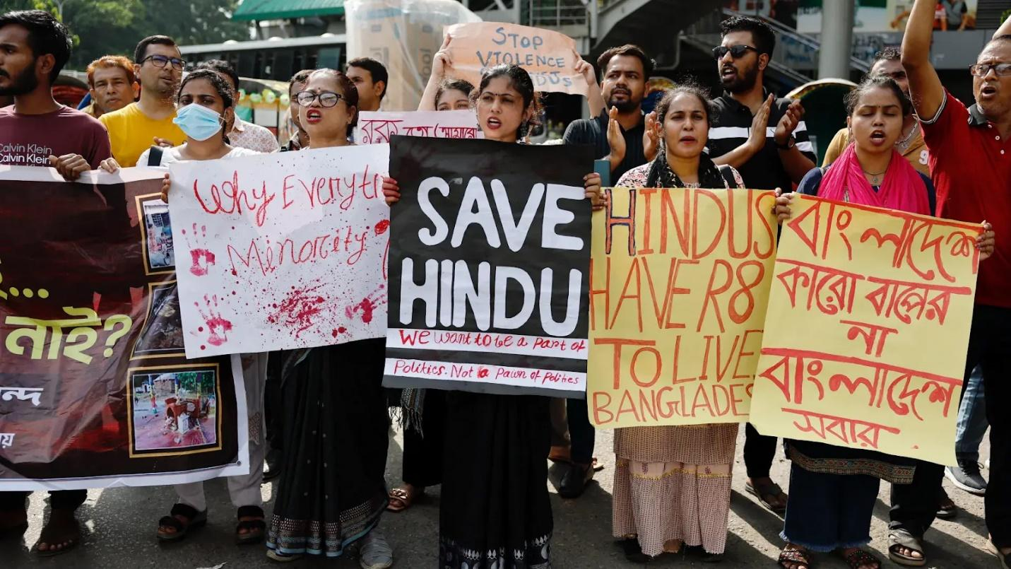
After the arrest of Chinmoy Das on charges of sedition, minorities faced the most severe form of repression that has not been seen since 2001under the BNP government of Khaleda Zia. International Bangladeshi and Human Rights organizations have risen to the occasion and continue to highlight the plight of Bangladeshi minorities. Human Rights Center for Bangladesh, Human Rights Congress for Bangladesh Minorities, Indian Subcontinent Partition Documentation, Hindu American Foundation, Coalition for Hindus of North America, Global Human Rights Defense etc. have worked on highlighting the plight of religious minorities. Still several cases of forceful conversion are found where Hindu women are being targeted, and they are being forcefully converted to Islam by different ways. A recent government report has shown that there has been a significant rise in the number of students in madrasas in Bangladesh.

The data revealed by the Bangladesh Bureau of Educational Information and Statistics stated that the number of students in madrasas increased to 2.75 million in 2023 from the previous 2.4 million recorded in 2019. At the same time, the number of students in secondary schools decreased from 9.23 million in 2019 to 8.16 million in 2023. We could find that there is minimal growth in mainstream education. As a result of which, Hindus are being forced to study in the same education system as of the Muslims.

Md Yunus implemented an economy in Bangladesh that is based on microfinance; his company used to give loans to the villagers but that loan giving system is a bit unconventional in modern economy. The system was an old practice, in Bengal few people used to give loans known as Jotdar. They used to give money to the farmers and used to take an interest against their land or house or even the fishermen boat. These people used to work under the Jamindar, the feudal lord. When the farmer or fisherman failed to give back the interest these Jotdar used to seize their land or boat. A good few cases are there where the proclaimed interest was much more than the actual dues. As these farmers and fishermen cannot calculate these Jamindars used to convince those people with wrong calculation of interest and burden them with more that they are supposed to pay. Md Yunus introduced almost the same, but they kept a condition that a group of people can take a loan individually, but payment terms are collective interest to be paid by the group. If anybody fails, then that portion must be borne by the entire community rather than mortgaging their property.

In parallel to the above system, Gramin Bank operates in Bengal while in these days he took a good amount of loan-interest on the villagers. That puts a pressure on Bangladesh economy; moreover, he requested to provide a loan of almost 15 thousand crore (150 billion) TAKA Bangladeshi Currency from the Reserve Bank of Bangladesh. This is almost half of the GDP of Bangladesh and experts are worried about the future of Bangladesh economy due this sudden change in economic policy. On the political front, he is not an elected leader of Bangladesh, only article 106 of their constitution provides such a provision, that even if the Supreme Court of Bangladesh passes such an interim order. Waker-Uz-Zaman, Chief of Army Staff of the Bangladesh Army published a report that the Supreme Court didn’t allow Md Yunus with such an order. The logic is that Obaidul Hassan, the then Chief Justice of Supreme Court Bangladesh and his bench member Ataur Rahaman and seven other associates were in safe shelter of the Bangladesh administrative block during the transition on August 5th to 8th 2024. So, such an order may not be correct. This made Md Yunus appoint several advisors in his interim Government of which Kalilul Rahaman is National Security Advisor. He is claimed by the BNP as not a citizen of Bangladesh. Several others like Lamia Mujaheed, Asif Nazrul, Safikul Alam Sayed Rizwanur or Lutke Siddique are controversial characters who are in this advisory board.

Thus, it is recommended by United Nations Human Rights to all political actors:
- Prioritize de-escalation and prevent any further loss of life or injury.
- Refrain from reprisals against political opponents of all viewpoints.
- Uphold the rights to freedom of expression and peaceful assembly.
- Ensure protection of minority communities and refrain from any language or acts of incitement to hatred, discrimination or violence.
- Actively denounce any human rights violations or abuses, in particular, those committed by their own members or supporters, and advocate for measures to ensure accountability and prevent further violations and abuses.
- Ensure the transition is conducted in a transparent and accountable way that is inclusive and open to the meaningful participation of all Bangladeshis.

Timeline: UNHRC Recommendations vs. Reality in Bangladesh

1. Universal Periodic Review (UPR) — 2018 (Third Cycle)
In May 2018, Bangladesh accepted 178 of 251 UPR recommendations, many of them addressing minority rights, judicial reform, and protection from communal violence. Yet, a mid-term review by the World Organization Against Torture (OMCT) found that none of the 83 relevant recommendations were fully implemented, 30 were partially addressed, and 53 saw no progress at all (OMCT, Mid-Term Assessment of UPR Recommendations, 2021).

2. Indigenous and Religious Minority Rights
The Unrepresented Nations and Peoples Organization (UNPO) reported that Bangladesh failed to act on recommendations related to the Chittagong Hill Tracts Peace Accord. This accord stood for ending impunity for violence against indigenous peoples and ensuring defender protection. However, 57 out of 63 evaluated actions were not implemented (UNPO, Bangladesh UPR Implementation Report, 2021). Human Rights Watch also documented continued military surveillance, extrajudicial killings, and land grabbing in the region, even as Bangladesh claimed implementation of the peace accord (Human Rights Watch, Bangladesh: UN Rights Review Amid Violent Crackdown, Nov. 16, 2023).

3. 2024 Anti-Hindu Violence & Post-Uprising Period
Between August and December 2024, there were 2,184 incidents of communal violence targeting Hindus and other minorities (murders, rapes, arson, and destruction of property) often with little to no state intervention (Associated Press, Aug. 2024; Times of India, Aug. 2024). At a UNHRC side event in Geneva, activists alleged state complicity and warned that Bangladesh risked “becoming another Afghanistan, Iraq, or Iran” if these trends continued (Protect Bangladesh, Sept. 2024).

4. OHCHR Fact-Finding Report — February 2025
The Office of the High Commissioner for Human Rights documented that security forces killed an estimated 1,400 protesters during the July–August 2024 unrest, including members of minority communities, using live ammunition and excessive force. The report urged independent investigations, repeal of repressive laws, and consideration of International Criminal Court-level accountability (OHCHR, Report on 2024 Protests in Bangladesh, Feb. 2025).

5. Discriminatory State Institutions
The Bangladesh Hindu Buddhist Christian Unity Council (BHBCUC) revealed a sharp decline in minority representation in public service. Minority trainees in police academies dropped from 21.8% to just 8.96% in recent years. Similar exclusion patterns appeared in judicial appointments, lecturer positions, and government legal offices (Minority Watch, 2025).

Summary Table: Gaps Between UN Recommendations and Domestic Reality
UN / UPR Recommendation | Implementation Status
Protect religious & indigenous minorities | Minimal implementation: violence and impunity persist
UPR recommendations (2018 cycle) | 0 fully implemented; majority ignored entirely
Chittagong Hill Tracts Peace Accord | Unfulfilled; continued militarization and land disputes
Accountability for 2024 protest violence | No independent prosecutions despite OHCHR findings
Minority representation in state institutions | Declining; active exclusion from public roles
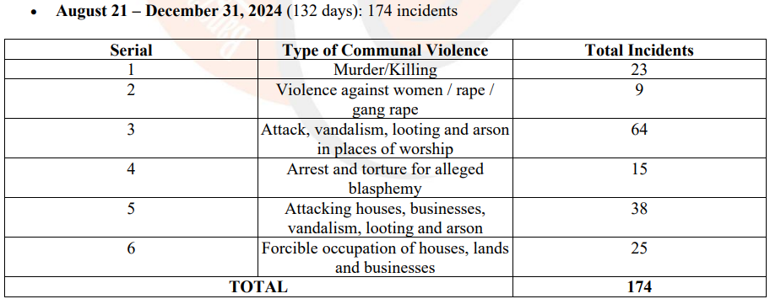

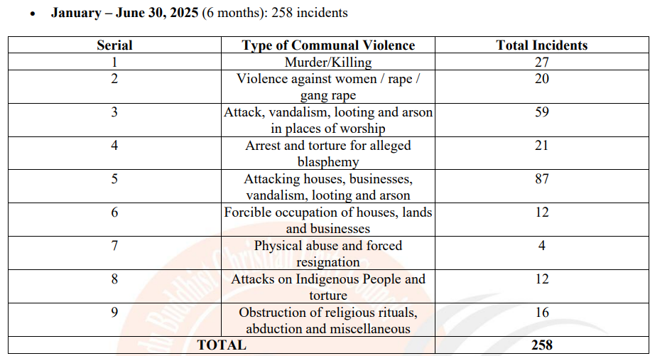

In the last year, the crisis of Gaza's civilians has topped international headlines. Mainstream media, the web, and social media have all given top billing to images of devastation, human misery, and calls for ceasefire in Palestine. World leaders have condemned; street protests have broken out in major cities; and the humanitarian situation has topped international political debate. All this frenetic coverage has, at least, been warranted—enormous civilian misery anywhere is worth paying attention to.

But a concurrent humanitarian crisis in Bangladesh—characterized by targeted violence, displacement, and institutional discrimination against the Hindu minority—has been met with virtual silence in the same global media space. In the second half of 2024 alone, more than 2,000 incidents of anti-Hindu violence were reported, involving mob violence, killings, sexual assault, burnings, and forced evictions. Villages have been razed; temples desecrated; families dispossessed of ancestral property on legal grounds. The cycles are not random but systemic, often breaking during times of political instability or religious festivals, and in most cases, facilitated by tacit complicity of the state.

Globally, though, reporting on these incidents has been restricted to short wire-service stories, usually stuck in the back pages or condensed to solitary paragraphs in South Asia summaries. No such op-ed explosion, photo essays, or primetime talks have ensued to personify Bangladesh's Hindu victims. The lack is all the more glaring considering that violence is not just routine but also systemic based on historical displacement such as the Vested Property Act, enforced through discriminatory policing, and sustained by impunity.

This gap in coverage is fueled by a set of factors. First, narrative selectivity: Gaza is an old geopolitical conflict to which Middle Eastern and Western publics are familiar and is therefore easy to narrate in terms of pre-existing moral templates. Persecution of Hindus in Bangladesh, on the other hand, is less familiar abroad, and is without powerful global lobbies or diaspora media networks to drum up sustained attention. Second, political discomfort: reporting on anti-Hindu violence in Bangladesh might be embarrassing to Dhaka, a valuable development partner of many Western governments, or challenge the "secular success story" narrative with which the country is typically sold abroad. Third, activist asymmetry: while Palestine is a symbolic cause for global justice movements, Bangladesh's Hindu minority has not been apotheosized to the same symbolic plane and therefore lacks a mobilized transnational solidarity network.

Its effect is a moral distortion: the rights and lives of Hindus in Bangladesh are treated as less newsworthy than other persecuted communities, almost by implication. It is not to belittle the suffering of Gaza, but to ask why sympathy and indignation cannot be universally applied. If the values of human rights and minority protection are universal, they must be applied equally to the torched houses of a Hindu family in Barisal as to the bombed hospitals of Gaza City. For the global press, silence is not just an omission but a dereliction of responsibility. By failing to report these abuses with the same energy, the world's leading news organizations allow violence in Bangladesh to germinate in the darkness. Without steady international scrutiny, there is no pressure on the Bangladeshi state to protect its minorities or hold abusers accountable. The silence is tantamount to complicity.

This four-month documentation report presents one of HRCBM’s most comprehensive recent civil-society assessments of continuing human-rights violations affecting Hindu and other religious and ethnic minority communities in Bangladesh.
(https://humanrightscongressforbanglade.box.com/s/p0c34hnx6w6mjg09j976pmcknvkn0v92)
The findings indicate that the documented incidents are not isolated or localized events, but reflect recurring patterns of violence, intimidation, sexual abuse, land dispossession, religious attacks, mob aggression, and institutional protection failures affecting minority communities across the country.

505 Documented incidents across 62 Districts at 8 Administrative divisions in 4 Months (January–April 2026)
The report identifies major categories of documented violations, including:

- 144 kidnapping and physical assault incidents
- 132 property attacks, land grabbing, arson, and looting incidents
- 100 murder and mysterious death incidents
- 95 temple attacks and religious vandalism incidents
- 28 sexual violence, rape, and gang rape incidents
- 6 blasphemy-related incidents

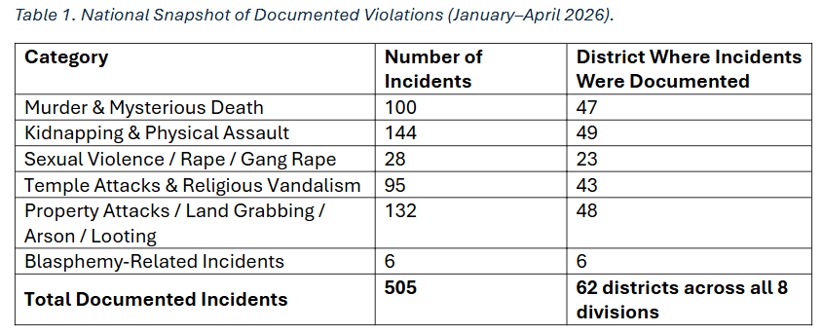

Property Rights, Religious Discrimination, and the Legacy of the Vested Property Act

Executive Summary
More than five decades after independence, Bangladesh continues to grapple with the human rights consequences of the Vested Property Act, formerly known as the Enemy Property Act. Although formally repealed, the Act’s legacy has resulted in systematic deprivation of land, housing, livelihoods, and cultural security of the Hindu minority.
As documented in the book Deprivation of Hindu Minority in Bangladesh: Living with Vested Property, this was not an incidental outcome of war-time legislation but a structural, religion-based system of dispossession that has reshaped demographic patterns, entrenched poverty, and weakened minority participation in public life.
Under international human rights law, the Government of Bangladesh bears an ongoing obligation not only to repeal discriminatory laws but also to provide restitution, compensation, and guarantees of non-repetition. The failure to do so constitutes a continuing violation rather than a resolved historical injustice.

Background of the Vested Property Regime
The Enemy Property Act was introduced during the Pakistan period to seize property allegedly belonging to “enemy” nationals. In practice, as extensively documented in the book, the designation was applied overwhelmingly and arbitrarily to Hindu citizens, regardless of citizenship status or actual absence from the country.
After independence, Bangladesh retained and renamed the law as the Vested Property Act, allowing confiscated property to remain under state control or to be redistributed to politically influential individuals. This continuity transformed an emergency law into a permanent mechanism of minority dispossession.
Despite repeal and subsequent recovery legislation, millions of acres remain unrecovered, and affected families continue to live with insecurity, displacement, and loss of livelihood (Living with Vested Property).

International Human Rights Violations

1. Arbitrary Deprivation of Property
The large-scale seizure of land and housing without due process, compensation, or effective appeal violates fundamental human rights norms.
Relevant international standards include:
- Article 17, Universal Declaration of Human Rights (UDHR)
https://www.un.org/en/about-us/universal-declaration-of-human-rights
“No one shall be arbitrarily deprived of his property.”
- Article 11, International Covenant on Economic, Social and Cultural Rights (ICESCR)
https://www.ohchr.org/en/instruments-mechanisms/instruments/international-covenant-economic-social-and-cultural-rights
Protects the right to an adequate standard of living, including housing.
The book documents how property seizures directly resulted in homelessness, landlessness, and economic precarity for Hindu families, often spanning generations.

2. Religious Discrimination and Inequality Before the Law
The selective application of the Vested Property regime against Hindu citizens constitutes institutionalized religious discrimination.
Violations include:
- Articles 2 and 7, UDHR – non-discrimination and equality before the law
- Articles 2(1) and 26, ICCPR – equal protection without discrimination
https://www.ohchr.org/en/instruments-mechanisms/instruments/international-covenant-civil-and-political-rights
The book demonstrates that Hindu identity itself functioned as a risk factor for dispossession, undermining Bangladesh’s obligations to protect religious minorities.

3. Denial of Due Process and Effective Remedy
Affected individuals faced systemic barriers in challenging seizures, including:
- Lack of access to land records
- Administrative opacity
- Intimidation and political interference
- Prolonged and ineffective legal proceedings
These practices violate:
- Article 8, UDHR – right to an effective remedy
- Article 14, ICCPR – right to a fair and public hearing
- Article 2(3), ICCPR – obligation to ensure effective remedies
The book provides extensive evidence that post-repeal restitution mechanisms remain inaccessible and weak, particularly for rural and economically marginalized families.

4. Forced Displacement and Demographic Impact
The systematic loss of land and housing has acted as a structural driver of migration, contributing to the steady decline of the Hindu population in Bangladesh.
Relevant standards include:
- Article 12, ICCPR – freedom of movement and residence
- UN Guiding Principles on Internal Displacement
https://www.ohchr.org/en/instruments-mechanisms/instruments/guiding-principles-internal-displacement
The book establishes a clear link between property deprivation and both internal displacement and cross-border migration.

5. Violation of Minority and Cultural Rights
Loss of land has undermined temples, cremation grounds, community spaces, and cultural continuity. Fear of seizure has discouraged political participation and public expression of identity.
Violations include:
- Article 27, ICCPR – right of minorities to enjoy their culture and practice religion
- Article 15, ICESCR – right to participate in cultural life
As documented in Living with Vested Property, dispossession has had deep psychological and cultural consequences beyond material loss.

State Responsibility under International Law
International human rights law is clear that:
- Repeal of a discriminatory law does not absolve a state of responsibility
- States must provide restitution, compensation, rehabilitation, and guarantees of non-repetition
The UN Basic Principles and Guidelines on the Right to a Remedy and Reparation
https://www.ohchr.org/en/instruments-mechanisms/instruments/basic-principles-and-guidelines-right-remedy-and-reparation
establish that victims of gross human rights violations are entitled to full and effective reparation.
Bangladesh’s failure to fully restore confiscated property or compensate victims therefore constitutes a continuing breach of its international obligations.

Key Advocacy Demands
Human rights organizations call on the Government of Bangladesh to:
- Ensure full restitution or compensation for all vested properties through transparent, time-bound procedures.
- Strengthen enforcement of recovery laws with independent oversight mechanisms.
- Digitize and secure land records to prevent future arbitrary seizures.
- Investigate and prosecute corruption and abuse linked to vested property transfers.
- Adopt minority-protection safeguards in land governance in line with ICCPR and ICESCR obligations.

Conclusion
As documented in Deprivation of Hindu Minority in Bangladesh: Living with Vested Property, the Vested Property regime represents one of the most enduring examples of law-enabled religious discrimination in South Asia. Its consequences—economic dispossession, forced migration, and cultural erosion—remain unresolved.
Without comprehensive restitution and accountability, Bangladesh risks perpetuating historical injustice and violating its commitments under international human rights law. Immediate action is required from the state, with sustained monitoring by Amnesty International, Human Rights Watch, OHCHR, and UN Special Rapporteurs on minority issues, housing, and freedom of religion or belief.

“While the Hindu elaborates his argument, the Moslem sharpens his sword.”
— Winston S. Churchill, speech at Albert Hall, London, 18 March 1931.
This line appears in the context of Churchill’s “Our Duty in India” speech delivered at the Royal Albert Hall on 18 March 1931, where he was discussing British India and what he saw as communal tensions between Hindus and Muslims. International Churchill Society
“Churchill by Himself: In His Own Words” (edited by Richard Langworth) lists this quotation and attributes it to the 18 March 1931 speech at Albert Hall. WMD Library
In that speech Churchill contrasted the political approach of Indian Hindu leaders—described as emphasizing argument and debate—with his characterization of Indian Muslims as more prepared for conflict, in his rhetorical framing of the communal situation in British India in the early 1930s.
Today also what, then, do we observe? In Bangladesh, members of the Hindu community have been subjected to brutal violence, including instances in which they were beaten and burned alive. Through the pervasive reach of social media, these acts have not only become visible to a global audience but have also revealed a disturbing phenomenon: mobs, driven by intense religious fanaticism, openly celebrating the violence, recording videos on mobile devices, and treating atrocity as spectacle.
Equally striking is the silence that follows. Groups and political actors who otherwise position themselves as vocal advocates of justice—whether as sympathizers of the Palestinian cause or as those quick to invoke narratives of “Hindu terrorism” in several cases —have maintained an unwavering and conspicuous quiet on these events. Such selective moral engagement raises troubling questions about consistency, credibility, and the politicization of outrage.
For those who argue that developments in Bangladesh bear no relevance to humanity, a reminder is necessary. Hargobind and Chandan Ghosh were sons of Bengal, politically under West Bengal. Even if they were not subjected to immolation, they were nonetheless brutally and unjustifiably hacked to death by Muslims on this soil. Geography and borders do not erase shared histories, cultural continuities, or the moral responsibility to acknowledge violence against one’s own civilizational community.
Dipu Das has shown that this time we could have organized ourselves—but even with this opportunity, we will once again pursue our own narrow interests.
The arrest of Chinmoy Prabhu has once again stirred the collective conscience of society. After a surge of protest arose within the country, its waves have begun to spread beyond national boundaries as well.
Our fundamental problem is that we think of nothing beyond our personal interests. We are unwilling to create a shared set of rules, to abide by those rules democratically, and to organize ourselves accordingly. This reluctance exists because adherence to democracy does not allow everyone the perpetual opportunity to become a leader; leadership in a democratic system must be earned through accountability and performance, by securing the support of others through tangible work. In contrast, leaders under a system of permanent authority act solely on their own will and compel others to accept their personal views as law.
In Dipu’s case, the government has come under pressure, which may lead to his arrest. However, given the potential loopholes in the application of law, there remains a strong possibility that he will eventually be released. When that happens, we will once again sink into despair—just as we have after the arrest of Chinmoy Brahmachari.
On issues of this nature, it is essential that legal and social forms of protest be determined through hours of careful discussion among experts. No such expert group has ever existed. A clear framework is required to determine how protests should be conducted both in society at large and on social media. We possess neither such experts nor the collective will or unity to convene and act together. Instead, we have 150 organizations, 600 ascetics, and 600 separate plans. Consequently, this time as well, we are likely to descend further into frustration and disillusionment.
We fail to understand that statements must be made in accordance with the law and without attacking others—this is something neither our so-called leaders nor the general public seem to grasp. We are weak in our use of language and expression.
Because we lack an expert group of lawyers, we do not even know whether Dipu’s father or his representative has been, or will be, made a co-plaintiff in the state’s prosecution of the case involving Dipu. Such legal processes also require financial resources. We have seen various appeals and advertisements asking for donations for Dipu’s father. Yet we do not know how to integrate all these aspects into a coherent strategy—what Dipu’s father’s approach should be, or what our collective strategy ought to be—because we have no guardian figure who sustains themselves through the honoraria we offer and works selflessly on our behalf. Even if a particular lawyer represents Dipu’s father, who can guarantee that they will not be compromised? Which institution or guardian will impartially evaluate the work of genuinely expert lawyers? Opposing forces will attempt either to intimidate our representatives into withdrawal or to buy them off through inducements.

Final Thoughts

The mistreatment of minorities in Bangladesh is entrenched in a history of grievances, institutional abandonment, and socio-political exclusion. In spite of the constitutional promise of equality before the law and religious freedom, the everyday life of most of the minority communities—Hindus, Christians, Buddhists, Adivasis (indigenous peoples), and linguistic minorities—is far from these guarantees. The cause of this malady is rooted in the long-term legacy of discriminatory legislation, including the Vested Property Act, which has long empowered the state to dispossess minority communities of land in the name of the nation. While the state has proceeded with ad hoc repeals and amendments, the rate of restitution has been glacial, leaving millions landless and disenfranchised. The failure to provide timely and unbiased justice further aggravates this systemic displacement. Meanwhile, the indigenous people of the Chittagong Hill Tracts continue to be victimized by forced assimilation, military occupation, and demographically driven displacement—despite the promises of autonomy and protection by the 1997 Peace Accord. These problems guarantee not only economic vulnerability but also a pervasive culture of fear and erasure among excluded communities.
One of the first steps towards countering this oppression is to consolidate legal protections and ensure equitable application. Legislation alone is not enough; the government must institute mechanisms that allow minorities to assert their rights without harassment or delay. This problem involves not just immediate policy of land restitution, but enactment of full-scale anti-discrimination legislation that imposes penalties on exclusion based on religion, ethnicity, language, caste, or disability. Establishment of a special minority rights commission or Ombudsman's office could be the key to monitoring such abuses and serving as an interface between victims and judiciary. All these efforts, however, must be followed by police and judicial reform, all too often showing collusion or insensitivity towards communal or targeted violence.

The second most important dimension is empowering the media and civil society. Human rights, community-based reporters, and local non-governmental organizations are pillars of strength for minority resistance; yet they are the ones being targeted. Repressive legislations like the Digital Security Act and the recently promulgated Cyber Security Act are systematically used to silence dissent and muzzle the work of challenging authorities. International support should thus be mapped towards defending democratic spaces—empowering grassroots organizations, upholding freedom of expression, and reinforcing the voice of minority opinion in national discourse. The media also have to be sensitized, especially in rural areas—to avoid perpetuating communal stereotypes.

Instead of putting minorities in the 'other' or marginal groupings, coverage must bring out their hopes, dilemmas, and contributions to the national tapestry.
No less significant is the need for inclusive development. The Bangladesh success story tends to ignore the plight of its minority community. For instance, indigenous children are not counted in school because they are educated in a foreign language, and disabled minority members face compounded discrimination. Policies need to go beyond charity and quotas; they need to target investing in community-led projects such as education, healthcare, employment, and skill development schemes. In addition, affirmative action schemes need to be fully supported through tangible budgets, segregation of statistics, and spot monitoring so that support reaches the most marginalized sections. Internationally, too, development organizations and donor agencies can help by linking the disbursement of aid to achieving human rights targets so that the government is forced to acknowledge and address inequality as a top national priority.

With economic and legal complaints, healing of social and emotional infrastructure in the country must also occur. Interfaith and intercultural dialogue must exist to rebuild trust among multicultural communities. Social cohesion can be neither legislated nor imposed but must be fostered. Community festivals, youth interfaith programs, and community truth-telling circles can promote a mutual understanding of one another's histories and traumas. Places of religion, such as temples, churches, pagodas, and mosques, need to be protected and sanctified as beacons of diversity and unity. The state needs to positively assert that any assault on religious or cultural expression is an assault on the republic.

Finally, visible accountability is needed. Bangladesh needs to extend an invitation to the UN Office of the High Commissioner for Human Rights (OHCHR) to establish a field presence in the country to document abuses of minority rights. This would not only be an international spotlight, but it would be a public sign that Bangladesh is serious about justice and about inclusion. The international community—South Asian neighbors not excepted—needs to be seen to be standing in solidarity with the oppressed not in virtue-signaling indignation but in diplomatic pressure, civil society solidarity, and fair reporting of abuses. In essence, ending minority persecution in Bangladesh is not a question of charity or tokenism but a call to the nation's moral and constitutional conscience. It is listening to what is unheeded, investing in what is neglected, and bringing the power to book when it discriminates. The solutions are not easy, but they are within grasp—if political will equals moral courage and people's power.

Bibliography
- https://bhbcop.org

- Associated Press. “Bangladesh violence evokes painful memories of 1971 for country’s Hindus.” AP News, August 11, 2024. (AP News)
- AP News. “A year after a bloody uprising, Bangladesh is far from political stability.” July 2025. (AP News)
- Reuters. “Bangladesh grapples with fraught politics a year after former PM Hasina fled.” August 5, 2025. (Reuters)
- Times of India. “Minorities under fire in Bangladesh: 2,442 hate crimes; ‘perpetrators enjoy impunity.’” June 2025. (The Times of India)
- AFP / France24. “Minorities fear targeted attacks in post-revolution Bangladesh.” December 22, 2024. (France 24)
- India Today. “Hindus in Bangladesh shiver amid attacks: Soft targets, hard facts.” August 13, 2024. (India Today)
- The Hindu / PTI. “Minorities faced 205 attacks after fall of Hasina-govt in Bangladesh: Hindu groups.” August 2024. (The Hindu, The Times of India)
- Hindustan Times. “Hindu idols in 3 temples vandalised in Bangladesh, 2 arrested amid violence against minorities.” December 21, 2024. (Hindustan Times)
- Wikipedia. “2024 Bangladesh anti-Hindu violence.” Accessed August 2025. (Wikipedia)
- Wikipedia. “Bangladesh post-resignation violence (2024–present).” Accessed August 2025. (Wikipedia)
- AP Archive (YouTube). “Bangladesh rights group accuses government of failing to protect minorities.” January 30, 2025. (YouTube)
- ArXiv – Academia. Paul, Abhijit, et al. “Where Journalism Silenced Voices: Exploring Discrimination in the Representation of Indigenous Communities in Bangladesh.” June 2025. (arXiv)

Appendix - 1

Persecution Categories Compiled by SoC
- Abduction / Kidnapping
- Alleged blasphemy
- Conversion by force/coercion
- Conversion by impersonation/manipulation
- Desecration of temple/shrine/image by beef/impurity
- Destruction of crop/fish/cattle feed
- Destruction of property/house/shop
- Destruction of temple/shrine/image
- Dismissal / Suspension for alleged blasphemy/crime
- Eve teasing / Advances
- Extortion from individual/temple
- Hate speech / Hinduphobia / Ant-Hindu slurs / Abuse
- Imprisonment / Fine for alleged blasphemy/crime
- Insult / Public humiliation
- Land grabbing / Eviction by force
- Land grabbing by forgery/manipulation
- Molestation / Rape / Gang Rape
- Murder / Mass murder
- Physical assault / Torture / Beating
- Robbery / Theft / Snatching of money/valuables
- Threat / Intimidation to vote/leave country

Appendix - 2

Administrative / Geographical Division of Bangladesh
The eight administrative geographical divisions of Bangladesh are:  - Barisal  - Chittagong  - Dhaka  - Khulna  - Mymensingh  - Rajshahi  - Rangpur  - Sylhet | 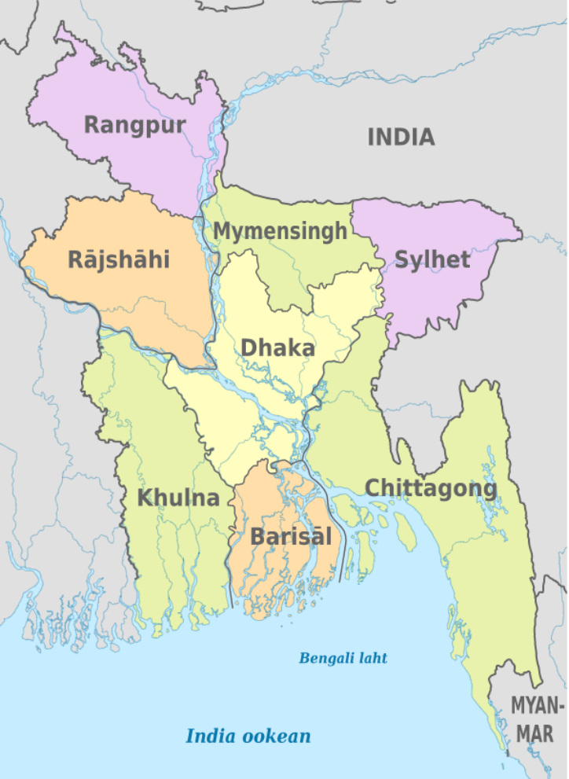

Appendix - 3
At Sriti O Chetona (SoC) we strive to cover as many stories as possible. However, due to lack of resources we are not able to cover all incidents. Only a handful of the occurrences get published. This section contains a selection of news reports on the persecution of minorities compiled by the SoC team between January 2026- June 2026

Dhaka: Hindu businessman beaten and set on fire by the miscreants from the majority community
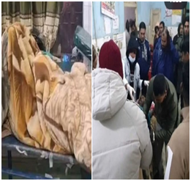 | January 2026 ; On January 2nd , Khokon Das, a Hindu man was brutally beaten up in Tiloi village under Shariatpur District in Dhaka division. Khokon Das is an owner of a small medical store in Tiloi Village. On January 2nd. he was dragged out of his shop and brutally beaten up by three miscreants representing the majority community of Bangladesh. Two persons were identified as Rabbi and Sohag. After Khokan Das was beaten up, the perpetrators poured petrol on his head and set him on fire. At the time of reporting, he was in critical condition in a Dhaka hospital.  The picture to the left shows Khokan Das being treated in Dhaka Hospital.
Rangpur: Hindu Deputy Commissioner Annapurna Debnath humiliated by Jamaat cadres
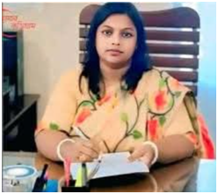 | January 2026: On January 3rd, the office of the Deputy Commissioner was harassed by Jamaat -e-Islami cadres. The incident happened in the Kurigram-3 area under the Rangpur division. The reason behind this ruckus was that DC officer Annapurna Debnath cancelled the election nomination papers filled by the Jamaat-supported candidate Mahabubur Rehman Saleh. Since the officer is from the minority Hindu community, the Jamaat followers found a reason to intimidate and bully her by calling Annapurna Debnath an ‘Indian agent’ and “ISKCON devotee”.  This extreme humiliation and insult was directed by Jamaat cadres at the Hindu officer.  Picture to the left shows Annapurna Debnath at her office.

Khulna: Hindu widow gang raped and her hair was cut forcibly
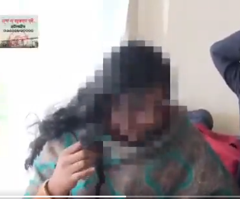  Picture above shows the tortured Hindu woman in Kheda para village of Kaliganj Upazila. | January:On January 5th, a horrific incident happened with a Hindu widow in Jhenaidah district. Two & half years ago, a Hindu woman legally bought a two-storey house and 3 decimals of land at the riverbank area of ward no.7 for BDT 20 lakh (USD 20,000). The property was bought from Shahin and his brothers. A few days later, Shahin kept coming back to the Hindu widow and gave her indecent proposals, and this happened repeatedly. The harassment continued for months, and the violence escalated on 5th Jan when Shahin and his friend entered the Hind woman’s home and raped her. They later demanded BDT 50000 from the woman. The cruelty continued with the woman when her hair was cut from her head by Shahin and gang. The incident took place in Kheda para village under Kaliganj upazila..

Khulna: Hindu businessman was shot dead by unknown assailants in public at Jessore
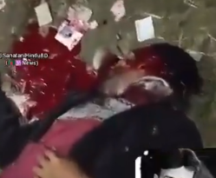 | January :On January 5th, a Hindu named Rana Pratap Bairagi was shot dead by the miscreants representing the majority community of Bangladesh. Rana Pratap Bairagi was a businessman in Jessore under the Khulna division.  He was not only a businessman but was also an acting editor of a newspaper. The incident took place in the Keshabpur area of Jessore on Monday. As per reports, some unknown assailants came and shot the Hindu man.  The picture to the left shows the bloody, dead body of the Hindu man Rana Pratap Bairagi.

Dhaka : Hindu businessman, Sarat Chakraborty murdered with sharp weapons for refusing to pay the extortion money
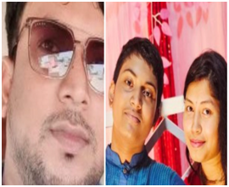 | January 2026:On January 5th, a Hindu man was killed with sharp weapons by the miscreants from the majority community of Bangladesh. He was identified as Sarat Chakraborty Mani, aged 40, who was a Hindu shopkeeper who was attacked at Charsindur Bazaar in Palash Upazila of Narsingdi district on the outskirts of Dhaka. The extortion was demanded from Sarat because he belonged to the Hindu minority community, and therefore, he had to pay Jizya tax to the muslim community.  The picture to the left shows Sarat and his wife.

Chittagong: Hindu minor girl Srabanti Ghosh brutally raped and murdered in her own house in lalkhan Bazaar of Chattagram
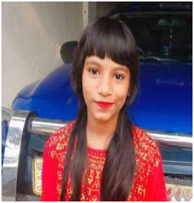  The picture above shows Srabanti Ghosh. | January 2026: On the night of January 6th, a Hindu minor girl, aged 12, was raped and murdered in Lalkhan Bazaar of Chattagram.  12-year-old Srabanti Ghosh was inside her home, and the incident took place between 10 pm and 11 pm. After committing the crime, the miscreants strangled the girl and staged it as a suicide by hanging her in her house.  Unfortunately, no one was inside the house to protect Srabanti. Her mother was working late at night as Srabanti’s father laboured away from home to run his family. They belonged to economically backward communities in Chattagram.

Sylhet: Hindu man was humiliated, physically assaulted in public, and later committed suicide in shame in Sylhet, Sunamganj, Dirai Upazila
January 2026: A man from the majority community of Bangladesh killed a Hindu man named Joy Mahapatra. The incident occurred in Sunamganj’s Dirai Upazila, under the Sylhet division. The entire episode unfolded when Joy, the Hindu man, purchased a mobile phone from a muslim shop owner for 5,500 BDT (USD 55). However, he paid BDT 2000 upfront, and the remaining was scheduled to be paid in weekly installments of BDT 500. Joy regularly paid the remaining installments but felt behind on the final installment.

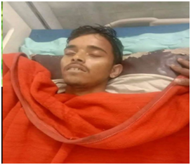 | This led Amirul Islam, the shop owner to take action against the victim and physically assault him very badly and on top of that Joy Mahapatra was humiliated in the public. After going through all this, Joy decided to poison himself when he went back home. Later on, he confessed to consuming rat poison and succumbed to death in the hospital.  The picture to the left shows the dead body of the Hindu man, Joy Mahapatra

Dhaka: Bangladesh authorities in Dhaka went out in the streets to ban musical instruments during the Hindu festival called ‘Makar Sankranti’
 | January 2026: On January 10th, the Islamic authority of Bangladesh openly insulted the Hindu community by going out in the streets and stopping music being played during a Hindu festival, ‘Makar Sankranti’. Islamists are rallying with a mega phone in Hindu majority areas and warning the minority community not to play any musical instrument in Dhaka.  The picture to the left shows the authorities out in the streets stopping the Hindu community for not playing musical instruments during the Makar Sankranti Hindu festival.

Chittagong: Samir Kumar Das, a Hindu autorickshaw driver killed by mob in Dagonbhuyian area of Feni district
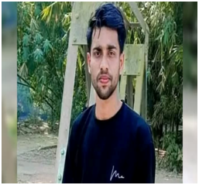  The above picture is of the Hindu man, Samir Kumar Das. | January 2026: On the night of January 11th, a Hindu man who was an autorickshaw driver by profession was murdered.  The incident took place in the Feni district of Chittagong division. The Hindu man named Samir Kumar Das was 28 years old and was attacked and killed by a mob that belonged to the radical majority community of Bangladesh. Samir Das was an autorickshaw driver in the Dagonbhuyian area of Feni district. As per police reports, he was robbed by the mob on the roads, and the assailants fled with his vehicle. An investigation is underway, but attacks on Hindu minority communities continue in Bangladesh.
Rajshahi: Popular Hindu singer and Awami League cultural secretary Proloy Chaki killed inside the police custody in Pabna
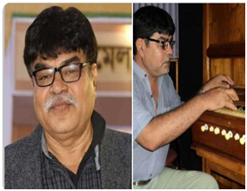 | January 2026: On January 13th , news floated that popular singer and Awami league’s cultural secretary Proloy Chaki died inside the police custody. The incident occurred in Pabna district of Rajshahi division.  On 16th December 2025, Proloy Chaki was arrested for associating himself with the Awami League. Sources said that he was tortured in police custody and eventually died. He was the former secretary of the cultural wing of Awami League's Pabna district unit.  The picture to the left shows Proloy Chaki.

Nine Hindus murdered in the first 18 days of January 2026
January 2026: 9 Hindus killed in 18 days of 2026.
Below is the name list.
1st January - Khokon Das.
5th January - Rana Pratap.
6th January - Moni Chakraborty
7th January - Shrabonti Ghosh.
10th January - Joy Mohapatro.
13th January- Samir Das.
17th January- Liton Kali Ghosh.
18th January- Avi.

The picture to the left shows the deceased Hindu’s in Bangladesh

Dhaka: Hindu man, age 23 burnt alive inside his own shop in Narsingi
 | January 2026: A Hindu boy named Chanchal Bhowmick was burnt alive by the miscreants from the majority community of Bangladesh. He was burnt alive inside his own shop on Friday in Narsingdi, Bangladesh.  Chanchal was sleeping inside his shop when the attacker shut the shutters, poured petrol, and set the building on fire. This is an outcome of a hate crime. The Hindu minorities are no longer secure in their own homeland.
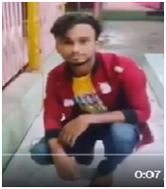 | Chanchal Bhowmick was a car mechanic and worked in his own shop. On the night of the mishap,Chanchal was sleeping inside his shop, and witnesses said the attacker remained outside the shop as Chanchal was charred to death.
Dhaka: Hindu families in Kishoreganj were tortured by the Bangladesh Army without any specific reason
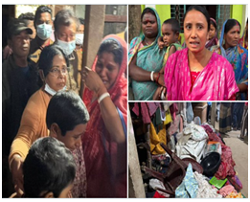 | Jan 2026; On Saturday January 31st , Bangladesh army carried out horrific tortures in the name of search on Hindu minority families.  At around 1.00 am in the night the Bangladesh Army carried out the search program identified the Hindu family and started beating them up. After this shameful incident when the Bangladesh army was asked to give reasons on such treatment given to Hindu families they could not give one specific reason. This happened in Dhanpur union of Itna zila of Kishoreganj.The sorrowful state of Hindu minority families in Bangladesh continues.  The picture to the left shows the traumatized condition of Hindu minority families in Kishoreganj Dhaka.
Rangpur: Miscreants from the majority community of Bangladesh destroy a musical instrument shop run by a Hindu man in MIthapukur

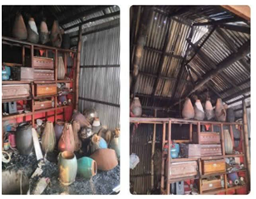 | Feb 2026 ; On Feb 3rd, thugs from the majority community of Bangladesh set ablaze a shop that was run by a Hindu minority. The incident took place in Mithapukur area under Rangpur district. It was a musical instrument shop run by a Hindu man. This heinous act was committed purely out of hatred. The musical instrument shop was completely demolished by the miscreants.  Picture to the left shows the demolished musical instrument shop.

Dhaka: Request for Hindu place of worship denied inside university premises even though structure for Islamic is approved
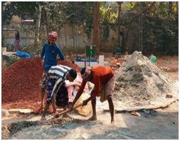  Picture above shows the washroom construction has started on the temple site inside Jagannath University. | Feb 2026; On Feb 4th, news came from Jagannath University, Dhaka, that Hindu students urged the management to construct a temple for them. Since there is already a mosque for the muslim students, the Hindu students wanted a temple to be set up inside the university premises. However, the administration has completely refused the appeal from Hindu students, and instead, they started building a washroom in a location where the students decided to construct their temple. This clearly shows that the ecosystem in Bangladesh is not in favour of the Hindu minorities, and they bear this kind of insult every day.

Sylhet: 28-year-old tea garden Hindu worker named Ratan Sahukar, murdered in Moulavibazar under the Sylhet division
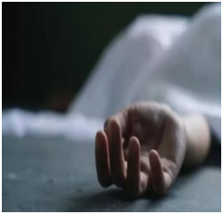 | Feb 2026; 24 hours before Bangladesh’s general elections, a 28-year-old tea garden worker was brutally murdered in Moulavibazar under the Sylhet division.  The man was identified as Rahul Sahukar. He was a Hindu minority man whose body was found in a mutilated condition inside the plantation on the morning of 11th February. Sharp weapons were repeatedly used to attack him. Police have started the investigation.  Attacks on Hindu minorities have been increasing day by day, as per the HRCBM reports, at least 115 Hindu persons were murdered between July and December 2025.  In January 2026, 14 Hindus lost their lives. This is the precarious condition of Hindu minorities inside Bangladesh.

Rangpur: Hindu minority village in Palashbari attacked and homes set ablaze
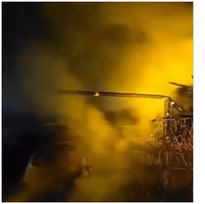 | Feb 2026; On the night of 11th February miscreants from the majority community of Bangladesh attacked a Hindu village called Palashbari. The radical members of this majority community set the hindu houses on fire. The minority Hindus of Phulbari Upazila faced the torture whole night and struggled to put off the fire that was set ablaze.  The incident took place in Phulbari upazila of Dinajpur district under Rangpur division.  The picture to the left shows the homes set ablaze
Rangpur: Hindu man murdered in Khamar Bollamjhar Village
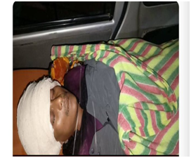 | Feb 2026; On the February 13th, a Hindu man was murdered with an axe. The name of the person was Sujan kumar Saha aged 38.  Sujan was a resident of Khamar Bollamjhar village under Gaibandha upazila of Bangladesh.  This heinous act was carried out by miscreants from the majority community of Bangladesh.  Rangpur division has become a living hell for the Hindu minority people.  The picture to the left shows the dead body of Sujan Kumar Saha.
Rangpur: Hindu man’s land grabbed and the victim evicted
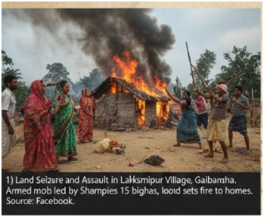 | Feb 2026; On the night of 13th February, a Hindu man’s land was forcefully grabbed by a local strongman named Shamim. The owner of the land is Nikhil Choudhury, who has 15 bighas of land under possession. All of a sudden, a group of miscreants belonging to the majority community of Bangladesh, headed by Shamim, entered Nikhil’s premises with weapons and intimidated the local Hindus. When the Hindus fled the place, the miscreants destroyed their properties and caused irreparable damage to Nikhil Choudhury and other Hindu minorities' properties. This suggests that land grabbing has become a popular means of carrying out torture on the Hindu minorities of Rangpur. The incident took place in Lakshmipur village of Sadullapur Upazila under Gaibandha district.

Chittagong: Miscreants from radical groups attacked Hindu houses
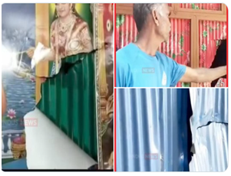 | Feb 2026; Miscreants from the majority community of Bangladesh, representing the political party, National Citizens Party, attacked the Hindu locality in Hatiya Upazila.  The radicals also attacked and vandalized the Hindu temples. Later on, they vandalized and destroyed the other Hindu houses. The incident took place in Hatiya Upazila of Noakhali district under Chittagong division.  The situation in Chittagong is very serious as the Hindu minority people face atrocities from the majority community.  The picture to the left shows the vandalized Hindu idols and their homes.
Chittagong: Hindu minority homes vandalized and set on fire
Feb 2026; On Feb 17th , 7 Hindu families were attacked in the Sonada union under Hatiya Upazila of Noakhali district. The attack took place on these Hindu families within 72 hours of Bangladesh’s 13th National Parliamentary Election. The houses were vandalized and then set on fire.The crime was committed by miscreants from the majority community of Bangladesh.
The Hindu minority community is still facing the brunt of Physical torture and vandalism of homes.
The picture to the left shows the kind of vandalism miscreants in Chittagong have done with the Hindu minority community.
Chittagong: Hindu man murdered for refusing to pay the extortion money (Jiziya tax)
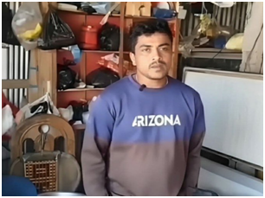 | Feb 2026; A Hindu man named Rajib Kumar Das was murdered in Sonagazi Upazila. Later on, the shop was completely vandalized by the miscreants. The reason behind this crude attack was later known to be that Rajib refused to pay Jiziya Tax (extortion money) to the miscreants, whom they demanded for his pan shop.  Rajib Kumar Das used to run a small pan shop in Sonagazi Upazila of Feni District, under the Chittagong Division.  The picture to the left shows Rajib Kuamr Das inside his shop.

Rajshahi: Hindu man from Harijan Colony murdered
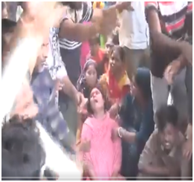 | Feb 2026: Muhammad Anik murdered a Hindu man named Sunil Basfor in Harijan Colony near Bogura railway station under the Rajshahi division.  This is nothing but an anti-Hindu pogrom, which is run by the majority community of Bangladesh inside the Rajshahi division.  Now the wife of Sunil Basfor and other local Hindus are staging a protest rally in front of the SP Office.  The picture to the left shows the traumatic condition of Sumil Basfor’s wife.
Chittagong: Hindu minority houses set ablaze in Rauzan
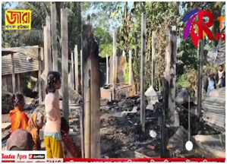 | Feb 2026; Chittagong has been witnessing the continuous torture and atrocities that are carried out on Hindu minorities. Hindu minority houses were completely vandalized and destroyed by the miscreants from the majority community of Bangladesh. The local authority came to the scene but couldn’t do much, apart from providing little compensation.  This incident happened in Rauzan Upazila under the Chittagong division.  The picture to the left shows the destroyed houses of Hindu minorities.
Dhaka: Hindu man in Koligram village brutally murdered
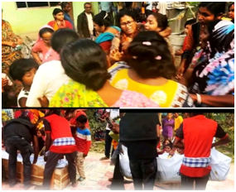 | Feb 2026; A Hindu man named Nishanta Baidya was murdered, and his body was dumped.  An eyewitness to this incident tells that Nishant was dragged out of his home by a radical element representing the majority community of Bangladesh. When he was dragged out of his home, he was brutally murdered.  This Hindu man was a resident of Koligram village in Jolirpur Union of Muksudpur Upazila under Dhaka Division.  The picture to the left shows the bereaved family members of Nishant Baidya.

Barisal: Hindu woman gang raped by the miscreants from majority community
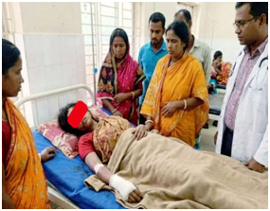 | Feb 2026; Miscreants from the majority community in Bangladesh have yet again committed a heinous crime against a Hindu minority woman. On the night of Feb 22nd, a Hindu woman was returning home from a Kirtan program, and suddenly a group of miscreants attacked the woman and gang raped her. The following morning, the locals found her on the roadside and admitted her to the hospital. She was being admitted to Bhola Sardar Hospital. The lady is a resident of Shayeshtakandi village, under Chandpur union of Bhola Upazila, in Barishal District..  The picture to the left shows the lady in the Bhola sadar hospital who was brutally tortured.
Sylhet: Hindu family attacked by Jamaat-i-Islamist political outfit
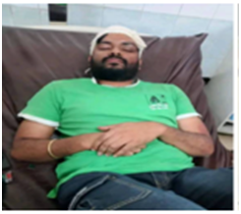 | Feb 2026: A group of miscreants from the majority community of Bangladesh attacked a Hindu family in Gotatikar Paittypara area in Sylhet city under ward no.7. The event unfolded on the night of February 20th, where four members of a Hindu family, namely Rajesh Ray, Rahul Ray, their elderly mother, and Rahul’s wife, Laboni, were badly assaulted by the miscreants. The miscreants from the Jamaat-i-Islami-affiliated outfit. They forcefully entered the Ray family and physically assaulted them.  The picture to the left shows one of the family members of the Ray family brutally injured.
Dhaka: Hindu temple in Golakandail village set on fire by miscreants from a radical religious group
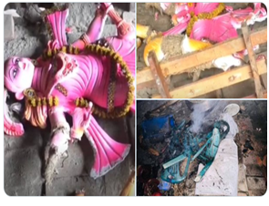 | Feb 2026: In Golakandail village under Narayanganj district miscreants from the majority community of Bangladesh attacked Hindu temples and then put them on fire.  All murtis inside the temple were burnt and other temple objects were set on fire.  Golakandail village is under Rupganj upazila.

Barisal: Hindu man forcefully evicted by Zakir Bhuiya in Patuakhali
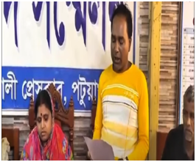 | Feb 2026: Gopal Mali, a Hindu resident of Patuakhali district, alleges that miscreants from a radical religious group of Bangladesh have forcibly occupied his share of land. The accused is Zakir Bhuiya, who counters Gopal Mali. Later speaking in a press conference, Gopal Mali accused Zakir Bhuiya of physical assault on him, and along with that, BDT 220000, and gold chains were looted from him.  The incident took place in Marichbunia, a village under the Pataukhali district under the Barisal division.  The picture to the left shows Gopal Mali holding a press conference in Patuakhali press club.

Chittagong: A 213-year-old Hindu temple land grabbed by the majority community of Chittagong, and peaceful Hindu protesters against the land-grabbing activity attacked by the miscreants
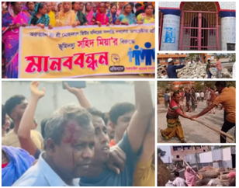 | Feb 2026: Radical mob representing the majority community of Bangladesh, led by Rokon Uddin, attacked a peaceful protest held by Hindu minorities.The protest was staged to oppose the alleged illegal occupation of land belonging to the 213-year-old Hindu temple, Shri Shri Mohanlal Jiu, in Bade Aruail village.  According to the eyewitnesses, local resident Shahid Mia and supporters attempted to obstruct the protest.Then Rokon Uddin, another miscreant, mobilised a large crowd of 20-25 men and started throwing stones at the Hindu minority protestors. The incident took place in Brahmanbaria district under Chittagong division.  The picture to the left shows the atrocities carried out on Hindu minority protestors.

Rangpur: Miscreants from radical religious groups destroyed and vandalized Hindu Goddess Ma Kali temple in Thakugaon district
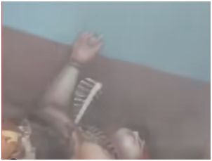 | Feb 2026; On the night of Feb 27th, a group of miscreants from a radical religious group entered a Hindu temple and completely vandalized the temple property, including the Goddess Ma Kali idol. In ward no.9 of Ranisankail Municipality, located in Thakurgaon district, there’s a famous, highly spiritual Hindu temple named Shri Shri Banakali Temple, where lots of people from the Hindu minority section of Rangpur used to visit. Today, due to the torture and violence, the idol of Goddess Banakali lies destroyed. The destruction of temples by the majority community of Bangladesh has now become a common incident in the Rangpur division.  The picture to the left shows the broken Goddess Kali idol.
Khulna: 300 Hindu minority women form a human chain in protest of denying their voting rights
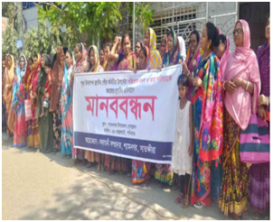 | March 2026; Human chain formed by the minority Hindu women in protest against a Bangladesh National Party member who threatened the Hindus specially the women in casting their vote. The incident took place in Chandipur village under Shyamnagar upazila of Khulna division.  300 women from Hindu minority community gathered around Shyamnagar Upazila press club to form a human chain and they called for their rights to live safely in their ancestral land and exercise their democratic rights.The threat received from several political leaders clearly suggests Hindu minority families are subject to public humiliation.  The picture to the left shows the protesting Hindu women forming a human chain.

Chittagong: Hindus attacked and temple premises destroyed by radical elements in Comilla
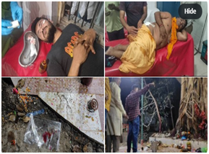 | March 2026: On March 7th,news came in from Thakurpara Kaligacchtala area of ward no.8,that bombs were hurled onto Hindus where they were performing their Shani puja. Several Hindus were injured and are now undergoing treatment in the hospital.  This heinous act was committed by people from the majority community of Bangladesh.  Destruction of temples and murder attempts on HIndus are now common in Bangladesh.  The picture to the left shows injured Hindus undergoing treatment in a hospital.
Chittagong: Hindu man was murdered in broad daylight
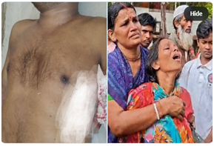 | Mar 2026; On March 7th, miscreants from the majority community of Bangladesh murdered a Hindu man in the Pollankata area of 5 no. ward under the Coxbazar municipality of Coxbazar district under the Chittagong division.  This barbaric act was committed because the Hindu named Ganesh Pal failed to pay the extortion money, which in Islamic terms is known as the Jizya tax. It's a tax that is levied on non-muslims if one refuses to convert to Islam. The miscreant stabbed Gabesh Pal several times and eventually Shri Ganesh Pal was murdered in broad daylight.  The picture to the left shows the bereaved family member of the murdered Hindu man.
Dhaka: Garo tribals evicted unlawfully by government authority
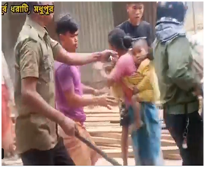 | Mar 2026; Authorities have started evicting the innocent tribals from their own land from Purbo Dhorati village under the Madhupur zila of Tangail district of Dhaka division.  The armed police are evicting the Garo tribals from their own land and homes. They are being tortured because they are weak.  The picture to the left shows the Garo tribals who are the victim of land grabbing and torture.

Barishal: Hindu boy killed by Muhammad Samrat and Muhammad Raju
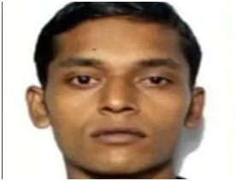 | March 2026; On March 15th, a Hindu boy named Gopal Chandra Das was brutally murdered in broad daylight in Pirojpur district under the Barisal division.  This heinous act was committed by miscreants from the majority community of Bangladesh. The main accused, Muhammad Samrat, has been arrested by the police, and his accomplice, Md. Raju is now absconding.  The picture to the left shows Gopal Chandra Das who was killed.
Khulna: Miscreants from the majority community murder the mother of a Hindu Police officer
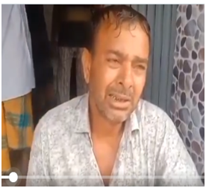 | March 2026; In the Bagerhat area, a Hindu Police officer’s mother was brutally killed. Suspected miscreants are from the Paikgacha upazila and belong to the majority community of Bangladesh.  Reports suggest that the miscreants murdered the woman named Bharati Mondal, by slitting her throat and then throwing her body in a pond. The next morning, the officer’s mother's dead body was recovered.  The picture to the left shows the man who lost her mother.
Dhaka: Hindu family looted and then physically tortured
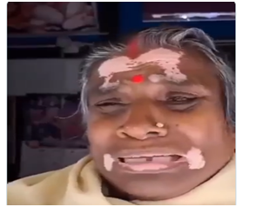 | March 2026; Miscreants from the majority community of Bangladesh attacked a Hindu family in Tarashi village in Gopalganj district.  Muhammad Didar and Muhhamad Atiyar and his gangs vandalized their houses, looted valuable things like gold ornaments and money. After all this, they didn't even spare the Hindu women. They physically tortured the woman of that Hindu family.  The picture to the left shows the sorrowful sight of a Hindu who was looted and physically tortured.

Chittagong: Hindu family faces insult and humiliation from the neighbours
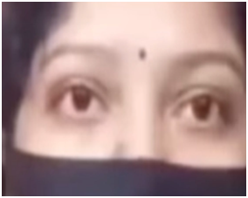 | March 2026; On March 21st, a Hindu family faced immense insult when they had restricted access to their own property in Banshkhali Upazila under the Chittagong division. The family further alleges that the harassment from the miscreants from the majority community escalated further, including restrictions on movement. limiting access to the primary pathway, verbal attack on Hindu children of the same family, discriminating behaviour compared to other neighbouring families, and lastly, the Hindu family has been constantly given a threat to vacate their own family.  The picture to the left shows the anxious face of the humiliated Hindu family.

Chittagong: Hindu man, Swapan Das(50), murdered in Patiya
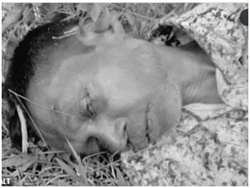 | March 2026; On March 27th, around 10 am, a Hindu man named Swapan Das, aged 50, went missing from the Chambhal bazar area in Banshkhali. According to sources, Swapan Das was a resident of Purba Denga Para village under Patiya upazila. Mysteriously, on 28th March, his body was found near the mosque in Banshkhali. He was murdered, and his body was dumped near the mosque. The family has demanded an impartial probe from the authority and raised concerns about the safety of the Hindu minorities staying in Purba upazila under the Chittagong division.  The picture to the left shows the dead body of Swapan Das lying on the ground.

Mymensingh: Hindu couple attacked, and an attempt was made to abduct the wife in the Kharika Beel, Madarganj upazila, Jamalpur
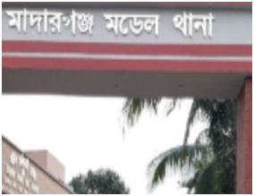 | March 2026: On the night of March 23rd, a Hindu couple, Ananta Robi Das, the husband, and Nishi Robidas, his wife, were returning home from a local Eid fair in Balijhuri, when all of a sudden, miscreants from the majority community attacked them and intercepted them in the Kharika beel area. According to reports, a few local youths started abusing the Hindu couple, and soon, when additional individuals joined the group, things got much more intimidating for Ananta Robidas and Nishi Robidas. Suddenly, the miscreants started attacking with weapons and attempted to forcibly abduct Nishi Robidas, but the locals immediately intervened, and the miscreants fled the place.  The picture to the left shows the Madarganj model Police Station.
Mymensingh: A 24-year-old Hindu with intellectual disability converted to Islam by an act of falsehood
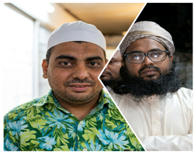 | April 2026 : 24-year-old Pritam Thakur, a physically challenged Hindu person, was converted to Islam in Narayan Dohor village. Pritam is a resident of Nagra Shivbari village in Netrokona Sadar. He left his home on the morning of 29th March and arrived at the religious center in Narayan Dohor under Purbhadhala upazila. He then embraced Islam under the guidance of preacher Wasim Nillah Nomani. He was renamed as Mohammada Yusuf after his coercive religious conversion.  The picture to the left shows Pritam Thakur with a white cap and a green shirt.

Rangpur: Hindu owned shops vandalized and looted
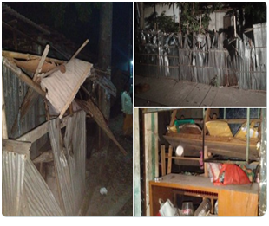 | April 2026: On April 11th a tragic incident occurred in Rangpur district of Bangladesh where Hindu owned shops were destroyed in Rangpur.  MIscreants from the majority community have attacked several Hindu homes in Rangpur.  Hindus were looted and shops were vandalized.  The picture on the left shows the vandalized shops that Hindus in Rangpur once owned.
Rangpur: Hindu man murdered by the miscreants
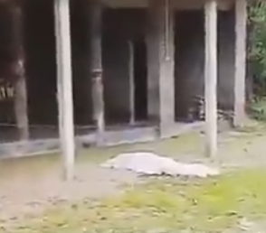 | April 2026 ; Suspected miscreants from the majority community of Bangladesh have murdered a Hindu Man in Shingi Bari village and left his dead body in front of a temple.  The police have started their investigation. The village falls under the Joldhka police station.  The incident took place on 14th April in Nilphamari district.  The picture to the left shows the dead body of the HInud man who was killed by the miscreants from the majority community.
Chittagong: A Hindu temple vandalized and looted
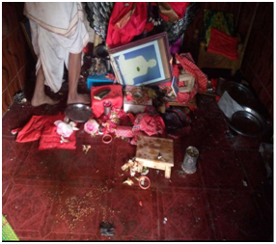 | April 2026: On the 16th of April, the two most revered temples of Bangladesh were looted, destroyed, and vandalized by the perpetrators of Rangunia upazila in Chittagong division.  The temples were the Ma Bhagbati temple and the Shiva temple. These were in Pomra Union.  As per the residents and the committee members of the temple, the perpetrators entered the temple premises in the darkness of the night and desecrated the idols, vandalized religious artifacts, and ransacked the interiors of the temple. This heinous act was committed by the miscreants from the majority committee of Bangladesh.  The picture to the left shows the vandalized condition of the inner sanctum of the temple.

Dhaka: 68-year-old Muslim man arrested for sexually assaulting a Hindu minor girl in Manikganj district
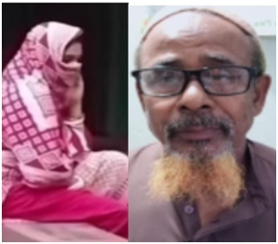 | April 2026; A 68-year-old man named Md. Sakimuddin was found guilty of repeated sexual assault on a Hindu minor girl, who later found to be pregnant. The event unfolded in Manikganj district under the Dhaka division.  This miscreant was a resident of a local village called Biswasbari. The police were quick to act and raided the Hangaj area of Satruria, which resulted in the arrest of this evil man named Sakkimuddin.The victim was a Hindu minor girl who was only in her ninth grade and was 7 months pregnant.  The picture to the left shows the perpetrator with a yellow beard and the victim, who is seen hiding her face.
Barisal: Hindu businessman hacked to death in Patuakhli
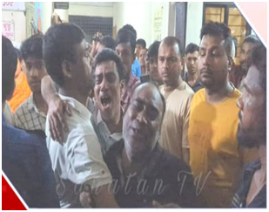 | April 2026: On April 2nd a Hindu businessman was brutally killed in Patuakhali district.  Ujjwal Karmakar was the victim who was beaten to death in Bauphal.  Even after the regime change the atrocities on Hindu minority in Bangladesh continues till date.  The picture to the left shows the bereaved family members of Ujjwal karmakar who was hacked to death.
Khulna: Moumita Halder, a school teacher brutally murdered by the miscreants from the majority community
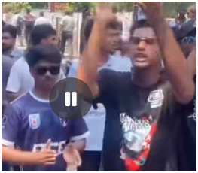 | April 2026; On April 3rd, a Hindu minority school teacher was brutally killed by miscreants from a radical religious group.  Victim Moumita Halder was a resident of Khulna. The CCTv footage, which was the only means of evidence, was tactfully removed, and now the Hindu community is out in the streets in protest of this heinous act.  The picture to the left shows the protestors in the streets for the brutal murder of Moumita Halder.

Dhaka: Teenager arrested in Dhaka for planning attacks on Hindu and Shia religious places of worship
April 2026; On April 4th, police arrested a teenager on suspicion of being associated with the banned militant organization 'Neo-JMB'. Police claim that he is accused of planning and instigating attacks on Shia mosques, police checkpoints and ISKCON temples through close associates. However, he has been sent to court as a 'child' as he is not an adult.

Dhaka: 42 Hindu families ordered to vacate their land by an Islamist in Savar upazila
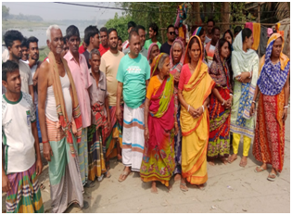 | April 2026; On April 4th, in Panpara Mohalla of Tentuljhara Union, 42 Hindu families were harassed by a local influential BNP supporter, Sohrab Uddin, by ordering them to vacate their homes because he claims that entire 92% of the Hindu land of Savar Upazila now belongs to him. This is a clear incident of eviction by force and land grabbing.  The picture to the left shows the bereaved hindu families in Savar.

Rajshahi: Hindus attacked in Joypurhat district by the Islamists
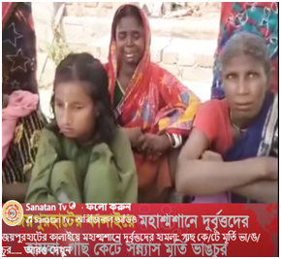 | April 2026; Islamists attack cremation ground which belongs to Hindus were under attack. Trees were cut in their properties and Vigrahas/murti were destroyed.This incident happened in Joypurhat district under Rajshahi division.

Khulna: Rabindranath Dhali’s home attacked in Sharankhola
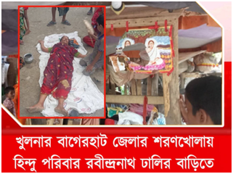 | May 2026; Hindus were attacked in Sharankhola, Bagerhat. Islamists attacked the house of Rabindranath Dhali and destroyed its property. They were also manhandled, and the ladies were physically tortured.  The picture to the left shows the vandalized property of Rabindranath Dhali.
Rajshahi: Hindu minor Pali Kumari abducted by professor Rabiul Alam
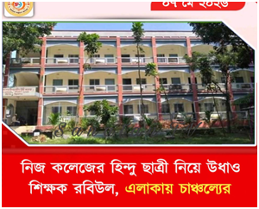 | May 2026; Professor Rabiul Alam eloped with minor Hindu girl Pali Kumari. A hindu minor girl abducted by an islamist in Rajshahi division under sirajganj district.
Chittagong: Minority children of the indigenous Mro tribe forcibly converted in Bandarban
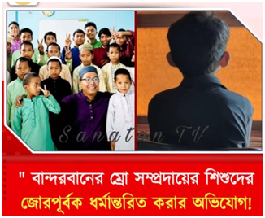 | May 2026; Allegedly, children of the indigenous mro tribe are forcefully converted in Bandarban, Chittagong. Minorities of Bangladesh are being persecuted in Chittagong, and the present government is not paying any attention to this matter.

Mymensingh: Hindu minor girl(12) raped and impregnated by her school teacher
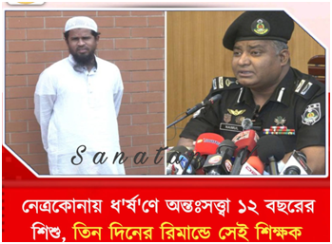 | May 2026, A Muslim teacher is arrested after he impregnated a 12 year old Hindu girl. This incident took place in Netrakona district under Mymensingh division.
Chittagong: Six Hindu families left homeless after their houses were set ablaze
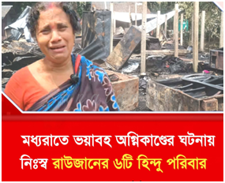 | May 2026; Miscreants from the majority community of Chittagong have committed a brutal act by setting houses of 6 Hindu families in Rouzan upazila. All Hindu families are now homeless and don't know where to go for shelter.

Dhaka: Hindus are humiliated in Dhaka via social media
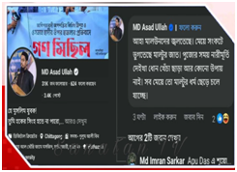 | May 2026; Islamists humiliate Hindus in social media. Administration is silent.

Chittagong: Hindu laborer brutally killed and her body dumped in a pond in Khagrachari
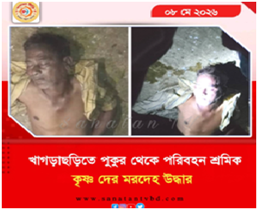 | May 2026: A Hindu minority woman was brutally killed in Khagrachari district under Chittagong division.  Body of worker Krishna De was recovered from a pond in Khagrachhari, Chittagong.
Mymensingh: Hindu man arrested for alleged blasphemy
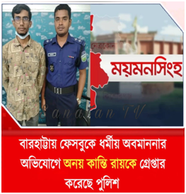 | MAY 2026; A Hindu man was humiliated and then put into trouble by a manufactured news of alleged blasphemy.  Hindu youth named Anay Kanti Roy arrested due to alleged blasphemy.
Chittagong: Hindu minor girl abducted by Mohammad Tanvir Gong in Bandarban district
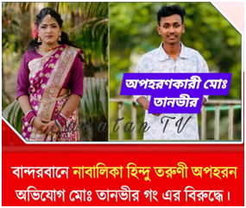 | May 2026; A minor Hindu girl was abducted in Bandarban, Chittagong. An alleged person named Mohammad Tanvir Gong is under scrutiny by the local authority.
Chittagong: Adi Nimkali Mandir ornaments and puja materials stolen from at Kalipur, Banshkhali, Chattagram
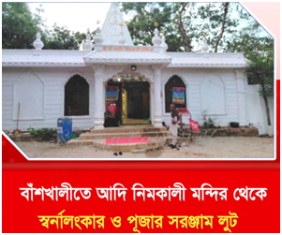 | May 2026: Miscreants from the majority community of Bangladesh has looted ornaments and puja materials from Adi Nimkali Mandir at Kalipur, Banshkhali, Chattagram. This incident took place in Banshkhali. Hindu minorities' religious places are not safe in Islam dominated Bangladesh.
Rajshahi: Hindu minor girl abducted by a Muslim teacher from Sadar Mohila College in Raiganj Upazila
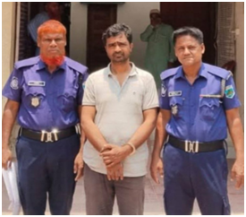 | June 2026; A Hindu minor girl went missing on June 1st from Sadar Women's college in Raiganj upazila. Poli kumari bhowmick aged 17 went missing from her home on May 5th. On May 6th her family filed a general diary in Raiganj police station and on May 31st when Poli kumari was rescued it was found that Mohammad Rabiul Alam a teacher in the same college had taken Poli kumari Bhowmick without her consent. They stayed at Gobindaganj area of Gaibandha district. The teacher was arrested immediately on abduction charges.  The picture to the left shows Md. Rabiul Alam is in a handcuffed situation.
Barisal: Miscreants from the majority community of Bangladesh set fire into Pirojpur Municipality crematorium
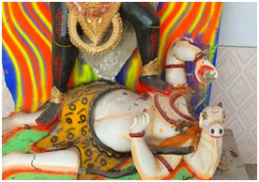 | June 2026: An incident of arson and vandalism occurred at the Kali Temple of the municipal crematorium in Pirojpur municipality. At that time, the miscreants took away the temple's prostration box and various cremation materials. Pirojpur Sadar Police Station Officer-in-Charge (OC) Mohammad Shariful Islam confirmed the matter. The incident is believed to have occurred between 3 am and 3:30 am on Monday (June 1).  The picture to the left shows the vandalized murti of Goddess Kali.
Sylhet: 16-year-old Hindu minor girl raped and murdered
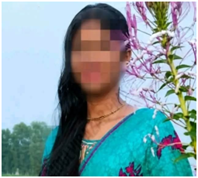 | June 2026; News coming in from Sylhet , Habibganj that a 16 year old Hindu girl named Nodi Das was brutally raped and murdered in Azimganj upazila.

Rangpur: Hindu man killed by the miscreants from the majority community
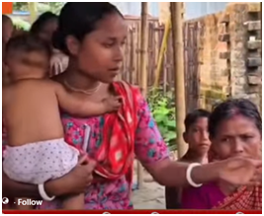 | June 2026 : A Hindu named Bishadhu is killed by Islamist goons at Jaldhaka Upazila under Nilphamari district of Rangpur Division of Bangladesh.
Rangpur: Hindu boy named Palash Roy wrongfully arrested for alleged blasphemy
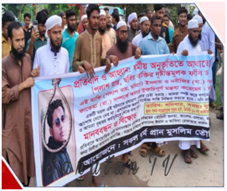 | June 2026: A Hindu boy named Palash Roy was arrested in Parbatipur upazila under Rangpur division. He was arrested for alleged blasphemy.

Sriti O Chetona stands for ‘memories and consciousness’ - memories of the once vibrant Hindu life and culture in East Bengal and the consciousness about the present plight of Hindus in Bangladesh. Sriti O Chetona is a not-for-profit project that regularly monitors and reports the ongoing incidents of persecution of Hindus in Bangladesh.

https://www.sritiochetona.org
sritiochetona@gmail.com

